Department of Computer Science
University of Houston – Victoria
Project Title:
“Glucose Tracker: A Monitoring and Reporting System for Blood Sugar Levels”
Team:
Salma Dali
Caleb Dowden
Erick Contreras
Instructor: Wenjuan Haung
COSC 4320 – Fall 2024

Table of contents
1. Abstract
2. Introduction
3. System-Level Diagram
4. Object-Oriented Solution
5. Database Tables
6. Flowchart
7. User Interface Design
8. Contributions
9. Glossary

1)Abstract:
The Glucose Tracker is a software application designed to support individuals with diabetes in effectively monitoring and managing their blood sugar levels. By integrating with glucose monitoring devices it collects real-time data which is stored locally and displayed through a user-friendly dashboard. These features allow users to track trends over time and gain a clear picture of their glucose patterns. The application also offers customizable alerts to notify users when glucose readings fall outside of target ranges. A key feature of the Glucose Tracker is its ability to generate shareable records allowing users to share their glucose data with healthcare providers. Future updates may include automated reporting and personalized insulin dosage recommendation to further enhance the user experience and provide rapid support for diabetes management.

2)Introduction:
Our Glucose Tracker project is designed to provide individuals with diabetes a simple and accessible tool for effectively monitoring and managing their blood sugar levels. Built around the goals of simplicity, accessibility, and streamlined tracking the project aims to support users in their daily routines to facilitate effective diabetes management. The Glucose Tracker integrates seamlessly with glucose monitoring devices capturing real-time data and displaying it in an intuitive dashboard. This interface allows users to effortlessly view, analyze, and share their glucose data to support a proactive approach to health management.
The application receives blood sugar data directly from compatible glucose monitoring devices in real-time and automatically records it within the system. This automated data capture removes the need for manual entry to ensure accuracy and ease of use for the user. Once the data is received it is organized, processed, and displayed in a clear and accessible format within the application dashboard. The display offers both daily summaries and longer-term trend views along with helping users identify patterns and understand their glucose levels over time.
In addition to real-time tracking and data organization the Glucose Tracker provides flexible options for sharing health information. Through the data export feature users can download their glucose history as a text file to make it easy to share with healthcare providers. This capability promotes continuity of care as healthcare providers can review patient records and adjust treatment plans as necessary. The Glucose Tracker contributes to a collaborative and responsive approach to diabetes management by offering a user-friendly and accessible way to share data.
Since the previous project report we have refined our core user requirements focusing on effective glucose data gathering, clear data presentation on the dashboard, and convenient data-sharing through a downloadable text file. We have also added notifications allowing users to set personalized glucose thresholds and receive alerts when levels fall outside their desired range. Currently the data is stored locally on the user’s device but future plans include integrating with an encrypted server for secure cloud storage. This enhancement will enable real-time monitoring granting healthcare providers instant access to data updates and improving responsiveness in patient care.
In summary the Glucose Tracker is progressing toward its goal of providing a straightforward and effective tool for diabetes management. With real-time data input, organized tracking, and shareable records the application empowers users to take control of their health. Future enhancements will give healthcare providers improved access to patients' data further enhancing support and engagement in diabetes management.

3) System-Level Diagram
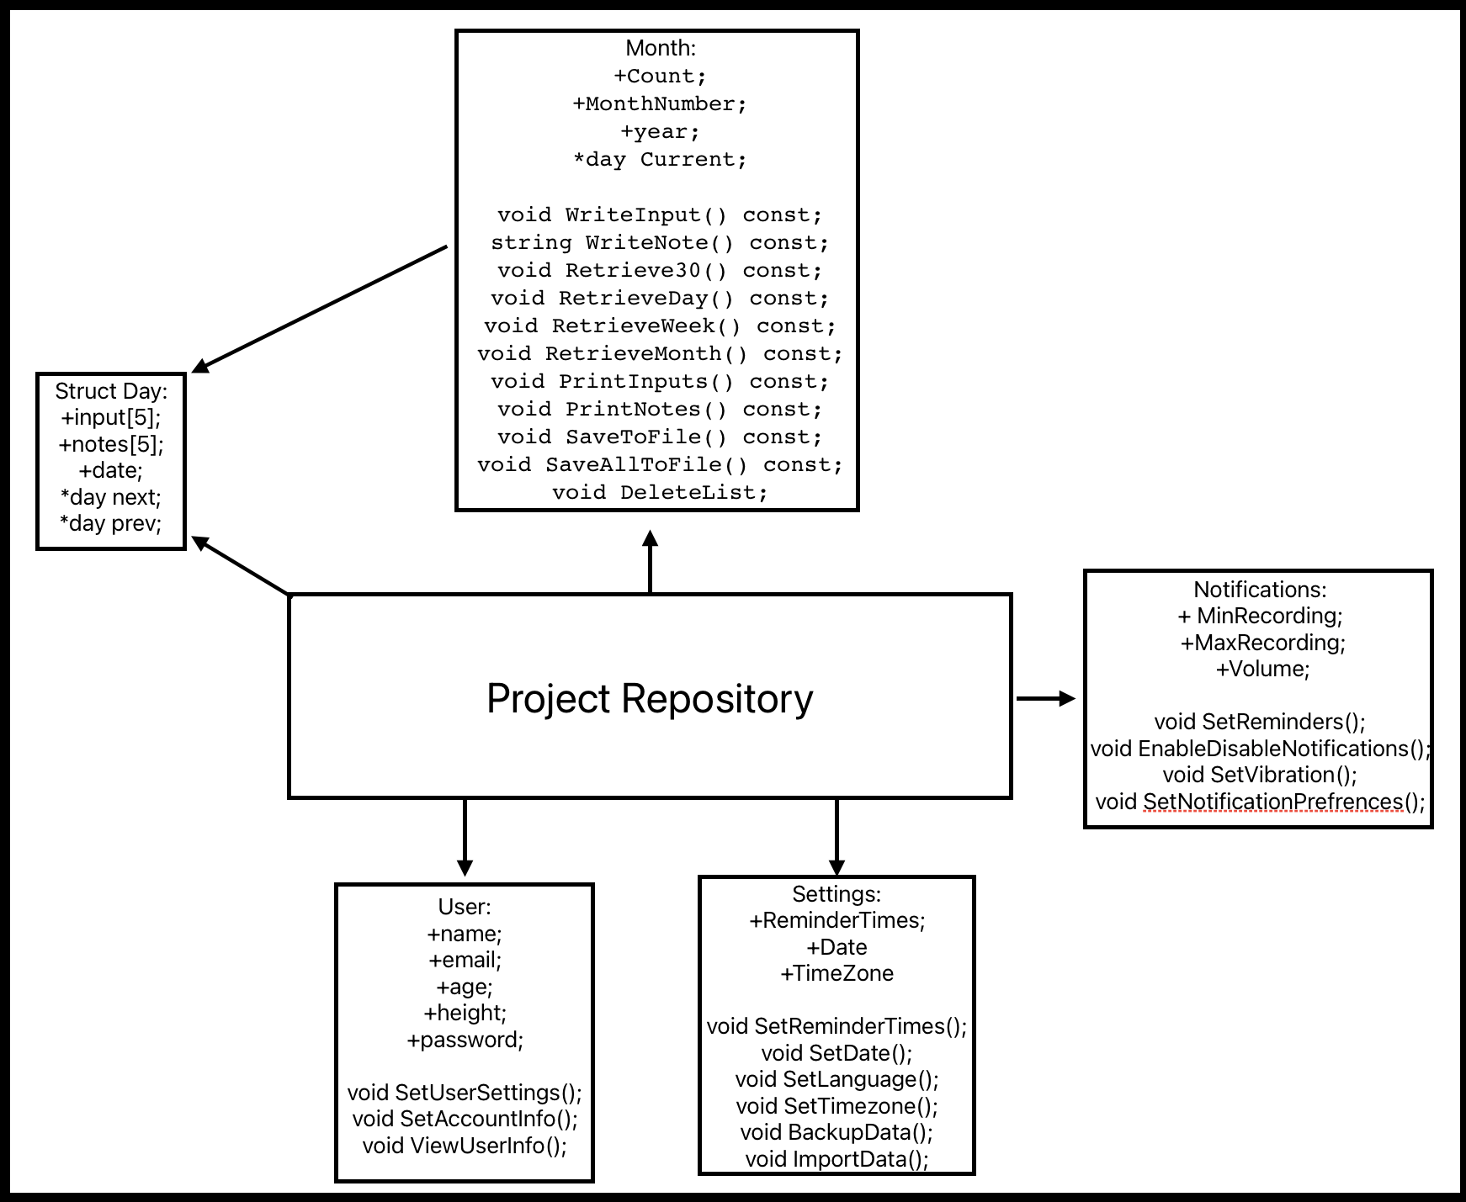

4) Object-Oriented Solution:
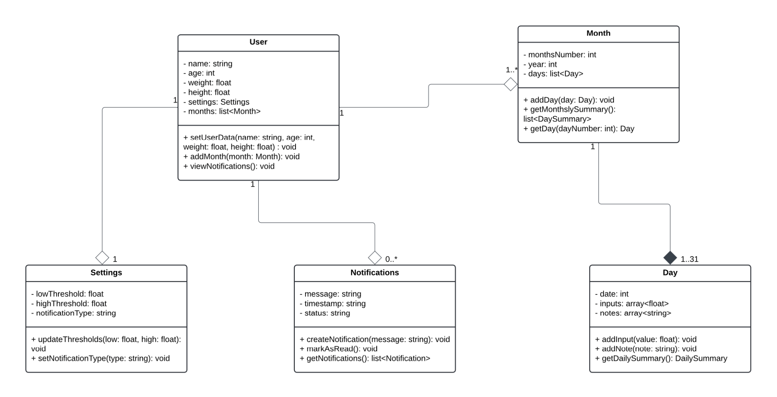

Class Descriptions
- User: The individual using the glucose tracker. It stores user information, preferences, and a history of monthly data.
Methods:
- setUserData: Allows the user to input or update their details (name, age etc)
- addMonth: Links a new month of data to the user
- viewNotifications: Displays all unread or acknowledged notifications
- Month: Represents a specific month of glucose data tracking. It organizes the daily data and provides summaries of the month’s glucose trends.
Methods:
- addDay: Adds a Day object for a specific date in the month
- getMonthlySummary: Calculates the trends, averages or abnormalities over the selected month
- getDay: Retrieves the data for a specific day
- Day: Grabs the daily glucose readings and any notes written that day
Methods:
- addInput: Records glucose reading for the day
- addNote: Allows the user to add notes to the day
- getDailySummary: Calculates and returns summary of glucose levels
- Notifications: Handles alert messages for abnormal readings and other notifications
Methods:
- createNotification: Generates a notification based on the trigger
- markAsRead: Updates notification status to “Read”
- getNotifications: Shows all notifications to the user
- Settings: Stores user preferences like the glucose threshold and notification types
Methods:
- updateThresholds: Updates the user’s glucose level threshold
- setNotificationType: Sets the type of notification (level alert, email, trends etc)
5) Database Tables
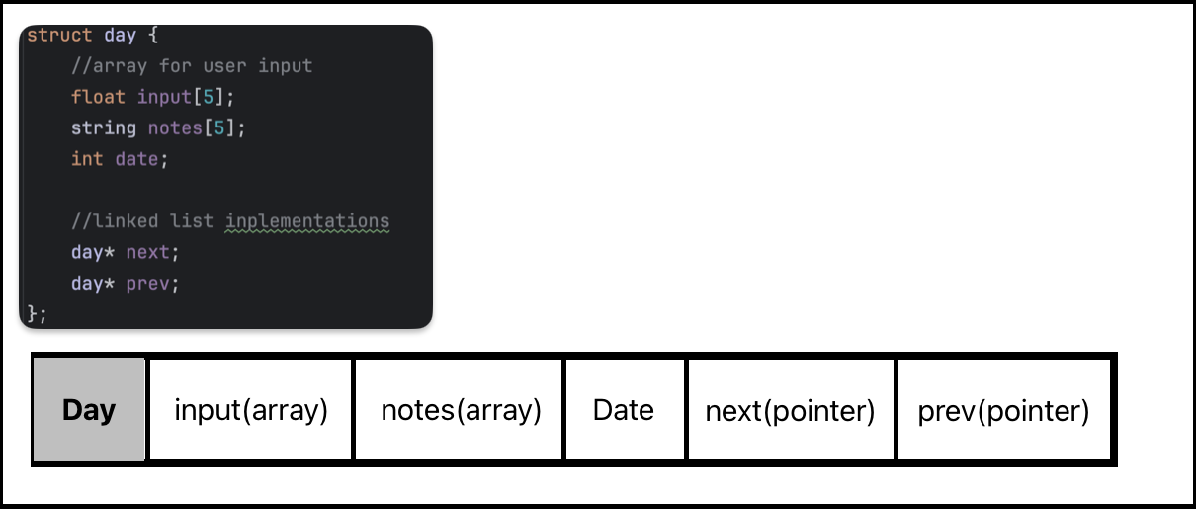
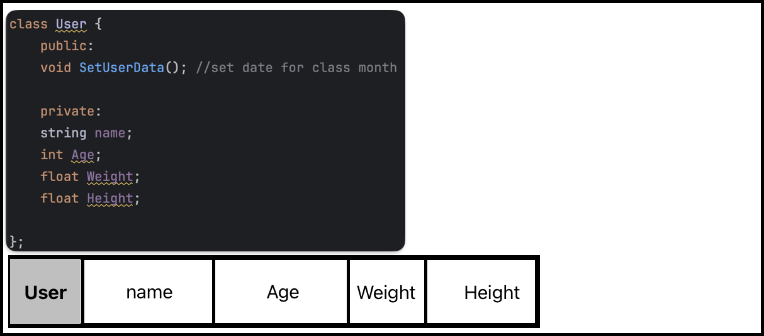
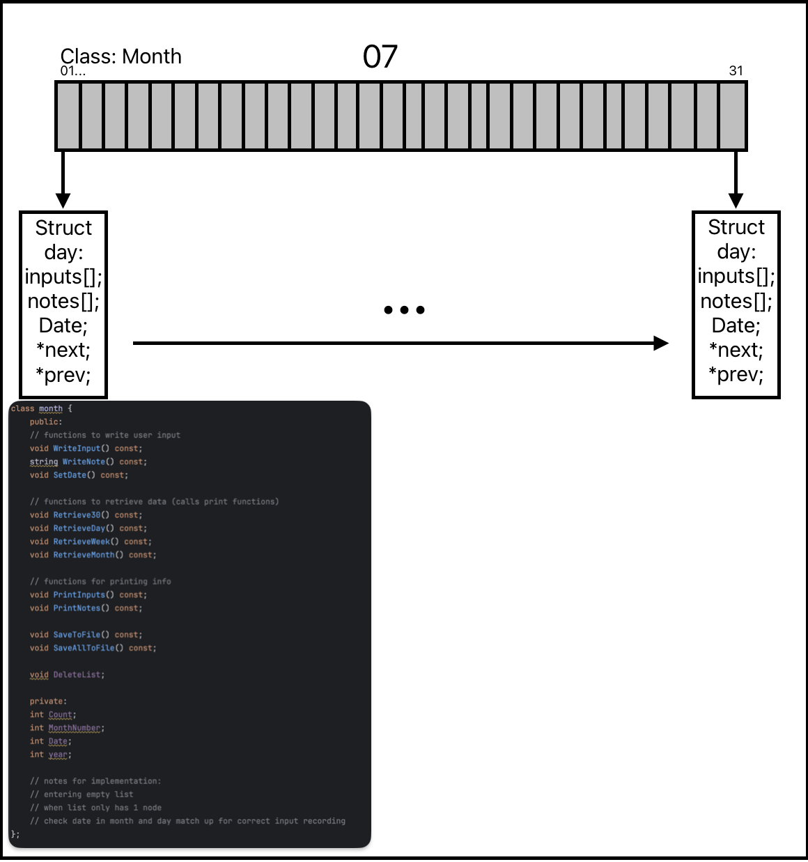

6) Flowchart
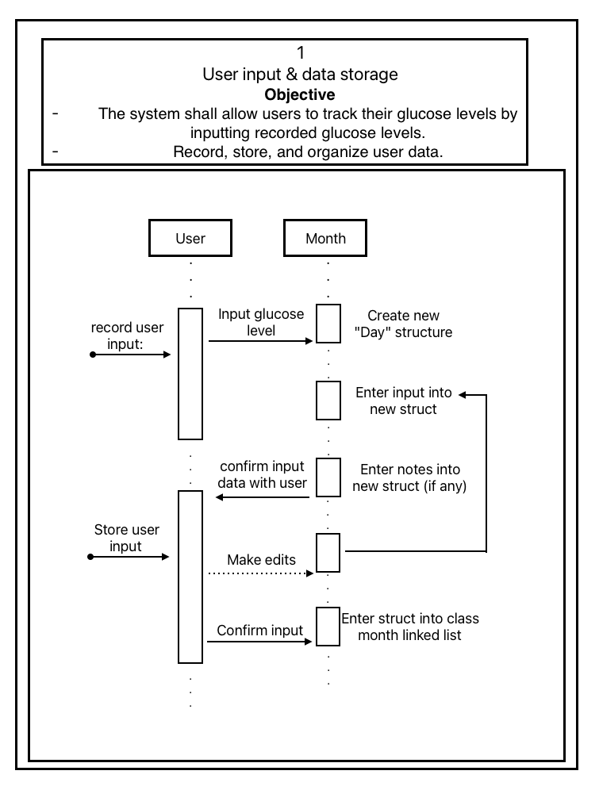
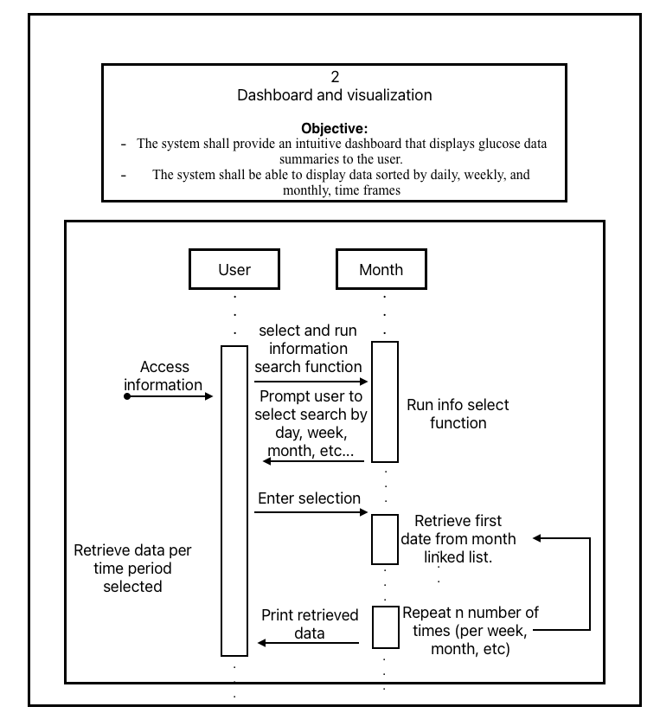
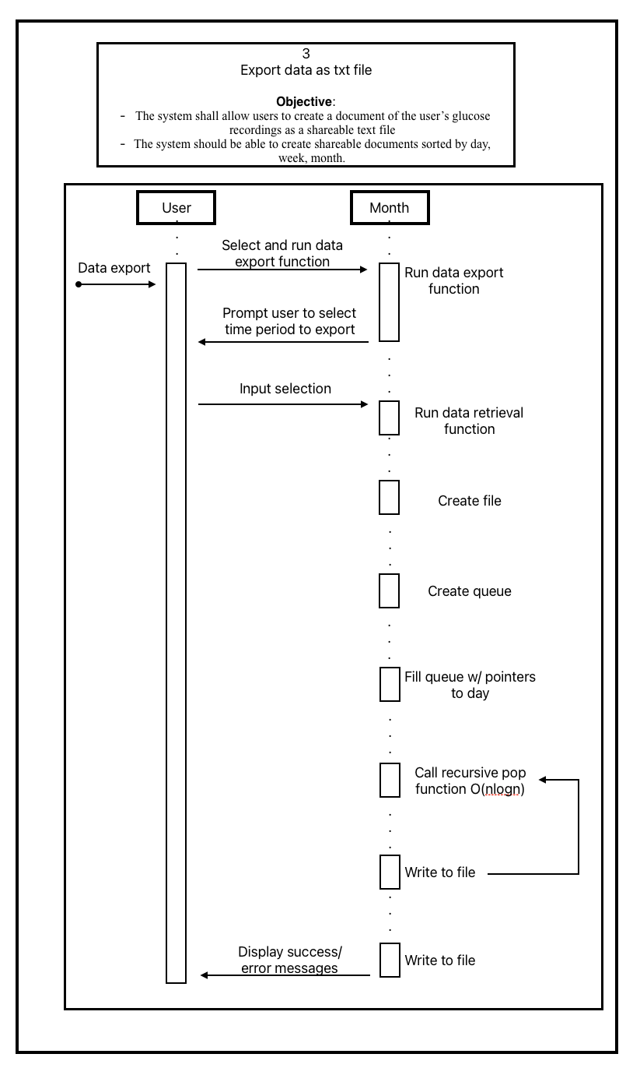

7) User Interface Design
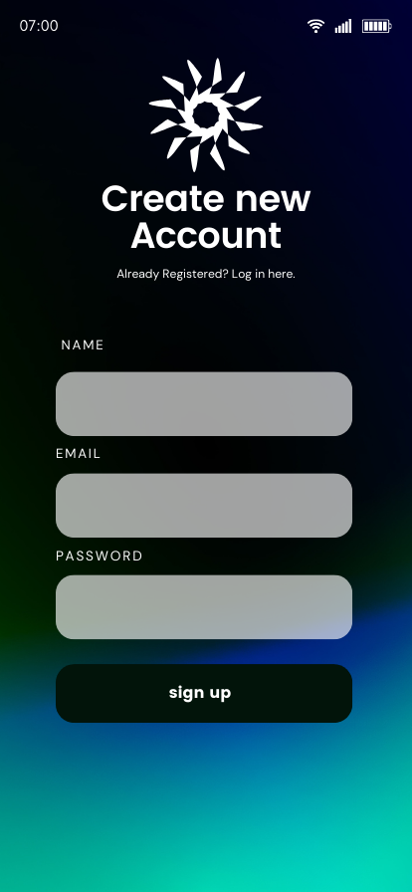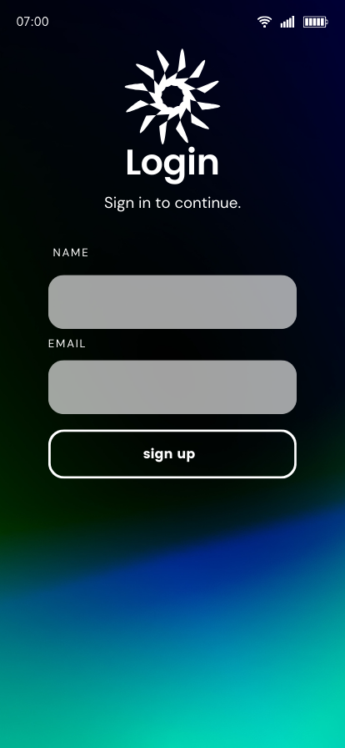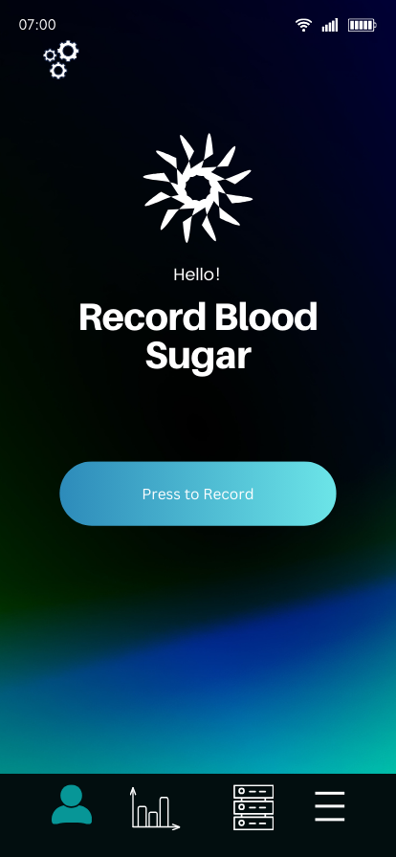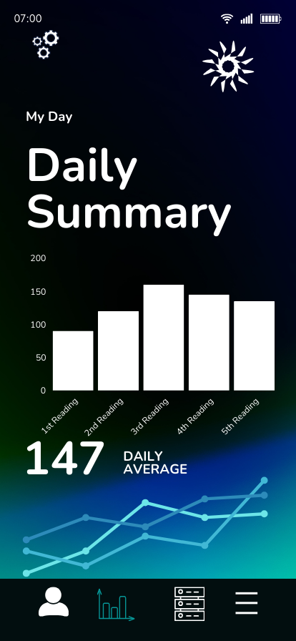
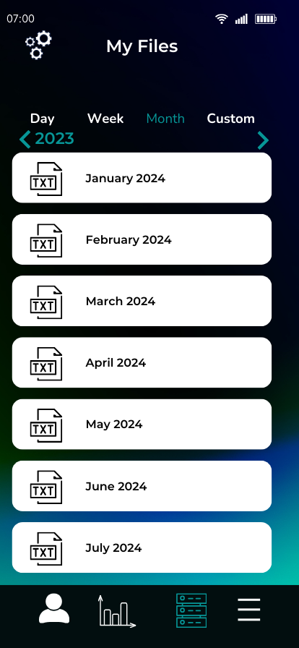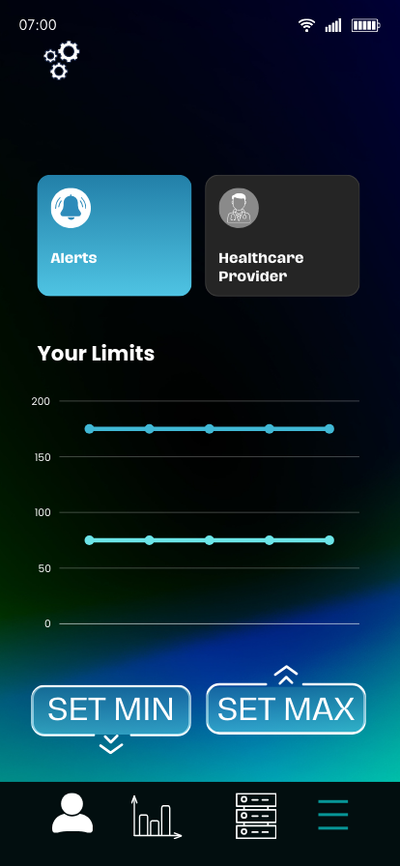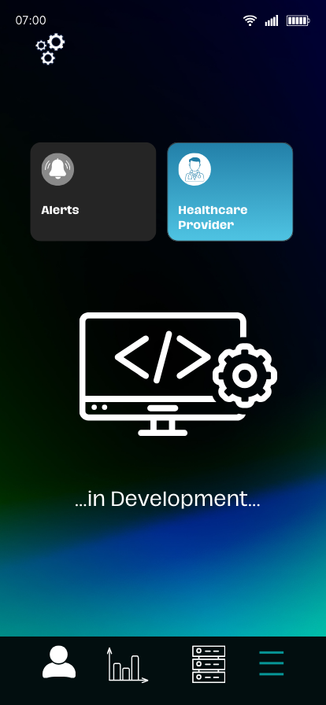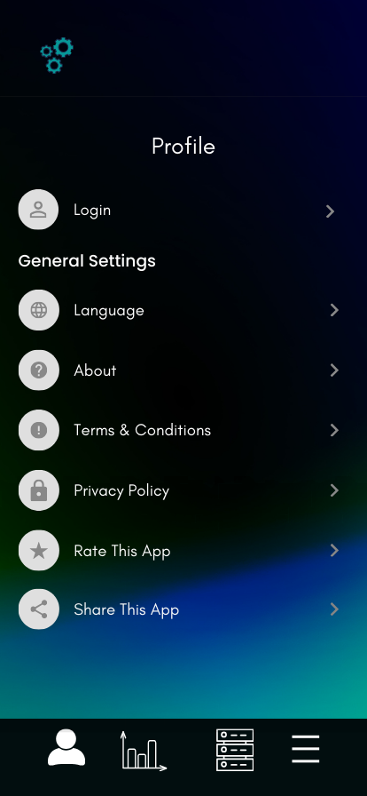
8) Contributions of team members.
Salma:
  - Object-Oriented Solution
  - Structing of software in program units
Caleb:
  - Database tables
  - Sequence diagrams
  - System Architecture diagram
Erick:
  - Abstract
  - Introduction
  - Glossary
  - User Interface Design
9) Glossary updates

Glucose Tracker: A mobile application designed to track, monitor, and manage blood sugar levels for individuals with diabetes. It provides real-time data, trend analysis, alerts, and data-sharing features to support effective diabetes management.
CGM (Continuous Glucose Monitoring): A device that continuously monitors glucose levels in the body, providing real-time data to the Glucose Tracker application. The CGM sends blood glucose readings directly to the app for automatic tracking and display.
API (Application Programming Interface): A set of protocols that allows different software components, such as the Glucose Tracker and CGM device, to communicate and exchange data. The API enables the Glucose Tracker to receive real-time data from monitoring devices and integrate with potential future cloud services.
User Dashboard: The main interface in the Glucose Tracker where users view current blood sugar levels, daily summaries, and trend analysis. The dashboard provides real-time updates and allows users to set thresholds, receive alerts, and export their glucose history.
Data Export Feature: A function within the Glucose Tracker that allows users to download their glucose history as a text file. This feature simplifies data sharing with healthcare providers.
Threshold Alerts: Customizable notifications that alert users when their glucose levels fall outside of predefined safe ranges. Threshold alerts support proactive diabetes management.
Cloud Storage: An encrypted, secure data storage option (future enhancement) that will allow glucose data to be stored on a cloud server, enabling real-time access by healthcare providers and remote monitoring capabilities.
Real-Time Monitoring: The ability of the Glucose Tracker to instantly receive and display glucose data as it is collected from the CGM device, providing users with up-to-date blood sugar levels.
Data Privacy and Security: Measures within the Glucose Tracker to protect user data through encryption and authentication, ensuring that health information remains private and secure, whether stored locally or in the cloud.
Healthcare Provider Portal: A secure interface (future enhancement) that allows authorized healthcare providers to access and review patient glucose data in real-time, supporting continuous care and timely adjustments to treatment plans.

